Design Specification Report

Calvert, Jadon | Edwards, Hannah | Meadows, Micah

CSC 440  Fall 2021

EKU Registrar Course and grade tracker

# Table of Contents

Table of Contents 1

Table of Figures 2

I. Introduction 3

A. Problem Statement 3

B. Proposal 3

II. System Description 3

III. System Requirements 3

A. Functional Requirements 3

IV. Use Case Diagram 10

V. Class Diagram 11

VI. Sequence Diagrams 12

VII. State Diagram 13

VIII. Activity Diagrams 14

IX. Database Design 20

A. ER Schema 20

B. Table Schema 20

X. Conclusion 20

XI. Data Dictionary 21

# Table of Figures

Figure I - Import Files Page 4

Figure II - Search Page 4

Figure III - Select Student from Table 5

Figure IV - Add Grade Form 5

Figure V - Select Student from Table 6

Figure VI - Edit Grade Form 6

Figure VII - Select Student from Table 7

Figure VIII - Edit Grade Form 8

Figure IX - Delete Grade Confirmation 8

Figure X - Select Student from Table 9

Figure XI – Save File Dialog 9

Figure XII - Use Case Diagram 10

Figure XIII - Class Diagram 11

Figure XIV - Sequence Diagram for Use Case Add Grade Files to Database 12

Figure XV - Sequence Diagram for Use Case Remove a Grade 12

Figure XVI - State Diagram 13

Figure XVII - Activity Diagram for Use Case Add Grade Files to Database 14

Figure XVIII - Activity Diagram for Use Case Add Individual Grades to Database 15

Figure XIX - Activity Diagram for Use Case Alter a Grade 16

Figure XX - Activity Diagram for Use Case Remove a Grade 17

Figure XXI - Activity Diagram for Use Case Print Report Card 18

Figure XXII - Activity Diagram for Use Case Print Transcript 19

Figure XXIII - ER Diagram 20

# Introduction

## Problem Statement

EKU’s Registrar Office needs to update student course records after receiving student grades from all the faculty at the end of each semester.

## Proposal

We propose a software system which will allow the EKU Registrar Office to efficiently update student records.

# System Description

The system includes three subsystems: a record importing subsystem, a record editing subsystem, and a report generation subsystem. The record import subsystem allows users to import records from excel spreadsheets into a database. The user can then add/remove/edit these records if they are incorrect using the record editing subsystem. The report generation subsystem will allow users to create transcripts from records in the database.

Import records

Search for records

Add records

Modify records

Delete records

Generate transcript

# System Requirements

## Functional Requirements

* + 1. The system shall allow for new grades to be added for each course into the database from multiple files at once.
       1. The user shall select “Import Records” from the top menu.
       2. The system shall prompt the user to browse for a folder containing the files.

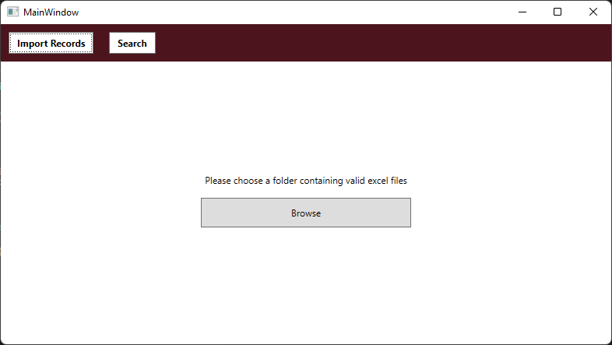

Figure I - Import Files Page

* + - 1. Once the user has browsed for the correct folder, the user shall click the “OK” button.
      2. The system shall process the files one by one and add their contents into the database.
    1. The system shall allow a user to search for specific students’ information.
       1. The user shall select the “Search” button from the menu bar.
       2. The system shall display a search prompt to the user.

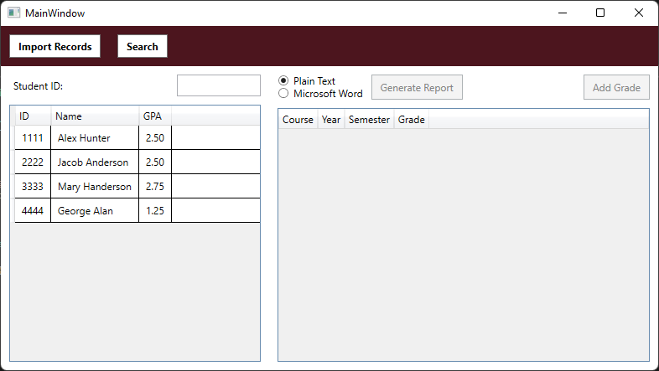

Figure II - Search Page

* + - 1. The user shall enter a student’s ID into the relevant text box.
      2. The system shall query the database and display resulting students in a list.
    1. The system shall allow for new grades to be added into the database manually.
       1. The user shall perform the steps in R3 to select the student in question.

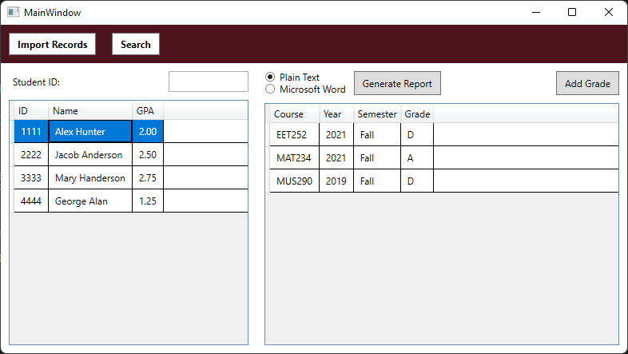

Figure III - Select Student from Table

* + - 1. With a student selected, the user shall click on the “Add Grade” button.
      2. The system shall display a popup form that will prompt the user to select a course and a letter grade from dropdown lists.

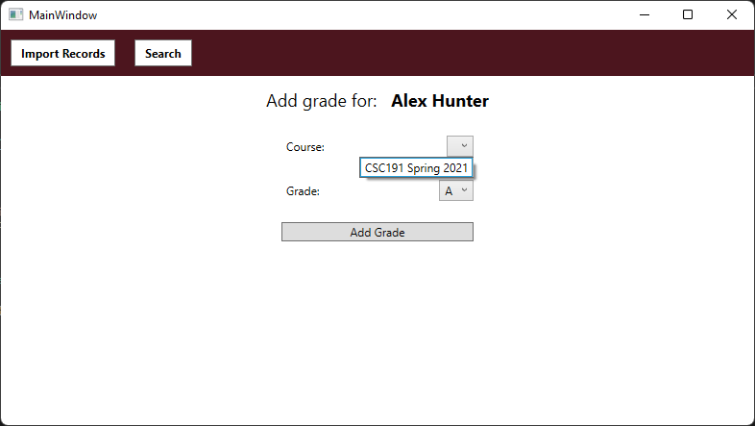

Figure IV - Add Grade Form

* + - 1. The user shall select the correct values from the dropdown lists and click the “Add Grade” button.
      2. The system shall add the new record into the database.
    1. The system shall allow for grades to be altered individually after they have been added into the database.
       1. The user shall perform the steps in R3 to select the student in question.

Figure V - Select Student from Table

* + - 1. The user shall select the incorrect grade from the table.
      2. The system shall present a form, populated with the current grade data in the database.

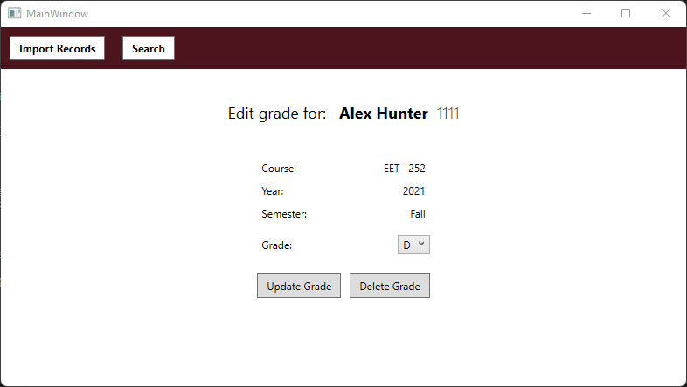

Figure VI - Edit Grade Form

* + - 1. The user shall choose the correct grade from a dropdown menu and click the “Update Grade” button.
      2. The system shall update the record in the database.
    1. The system shall allow for grades to be deleted individually after they have been added into the database.
       1. The user shall perform the steps in R3 to select the student in question.

Figure VII - Select Student from Table

* + - 1. The user shall select the grade to be deleted from the table.
      2. The system shall present a form, populated with the current grade data in the database.

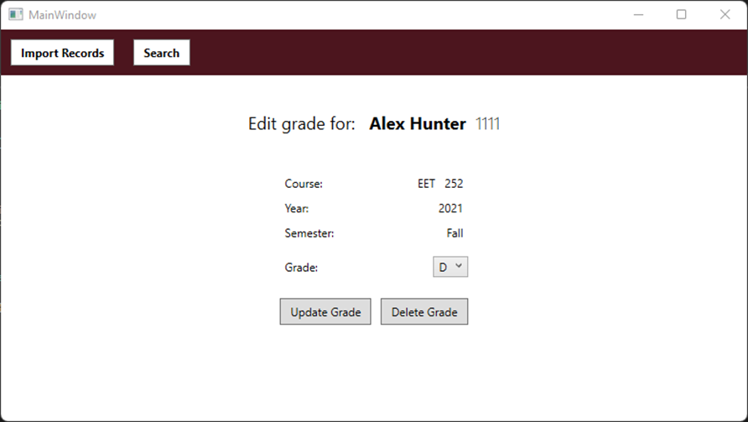

Figure VIII - Edit Grade Form

* + - 1. The user shall click the “Delete Grade” button.
      2. The system shall prompt the user to confirm whether they would like to delete the selected grade.

Figure IX - Delete Grade Confirmation

* + - * 1. If the user clicks “Yes”, the system shall remove the grade from the database and update the GUI.
        2. If the user clicks “No”, the system shall return to the edit grade screen.
    1. The system shall allow for the generation of a transcript containing all grades for a student.
       1. The user shall perform the steps in R3 to select the student in question.

Figure X - Select Student from Table

* + - 1. The user shall select between the different report options using the radio buttons.
      2. With the correct report type selected, the user shall click the “Generate Report” button.
      3. The system shall prompt the user to select a location on their computer to save the resulting report.

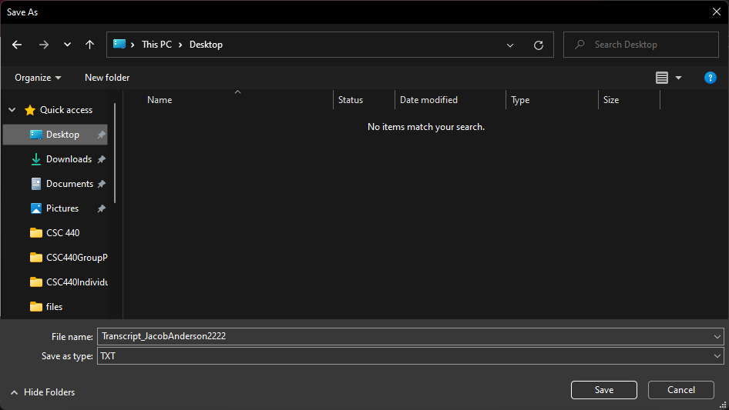

Figure XI – Save File Dialog

* + - 1. The user shall navigate to the folder they would like to save the report in and click the “Save” button.
      2. The system shall generate the report and save it to the selected location.

# Use Case Diagram

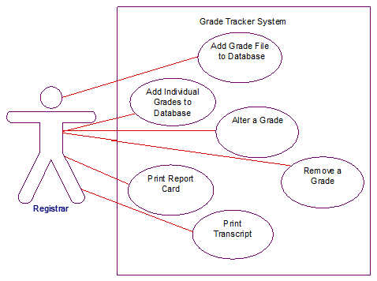

Figure XII - Use Case Diagram

# Class Diagram



Figure XIII - Class Diagram

# Sequence Diagrams

Figure XIV - Sequence Diagram for Use Case Add Grade Files to Database

Figure XV - Sequence Diagram for Use Case Remove a Grade

# State Diagram



Figure XVI - State Diagram

# Activity Diagrams



Figure XVII - Activity Diagram for Use Case Add Grade Files to Database



Figure XVIII - Activity Diagram for Use Case Add Individual Grades to Database



Figure XIX - Activity Diagram for Use Case Alter a Grade



Figure XX - Activity Diagram for Use Case Remove a Grade



Figure XXI - Activity Diagram for Use Case Print Report Card



Figure XXII - Activity Diagram for Use Case Print Transcript

# Database Design

## ER Schema



Figure XXIII - ER Diagram

## Table Schema

Student (ID, Name, GPA)

Course (Prefix, Number, Year, Semester, Hours)

Grade (Prefix, Number, Year, Semester, Grade)

# Conclusion

A system as described would provide the EKU Registrar’s Office with an easy and convenient method for managing student records.

# Data Dictionary

Database Context: opens the connection to the database/allows access

Course: a class that contains course information pulled from the database

Grade: a class that contains all information needed to store a grade

Student: a class that contains all information needed to know a student

View Model Base: a class that lets all other view models exist

Add Grade View Model: creates the GUI for the “Add Grade” feature and holds its functionality.

Edit Grade View Model: creates the GUI for the “Edit Grade” feature and holds its functionality.

Import Record View Model: creates the GUI for the “Import Record” feature and holds is functionality.

Navigation View Model: creates the GUI for the “Navigation” feature and holds its functionality.

Search View Model: creates the GUI for the “Search Student” feature and holds its functionality.

Report Generator: a class that is the basis for all typed of report generation

Docx Report Generator: a class that exports a docx report

PDF Report Generator: a class that exports a PDF report

Plain Text Report Generator: a class that exports a plain text report